Implementation of Sutte Indicator to Predicting Movement of Stock of Apple Inc.
Penulis 1¹, Penulis 2², Penuliske3³,etc
{oke_sekali@xxx.org¹, email address penulis ke-2²... sampai 3 penulis }

Affiliation Here¹, Affiliation Here²
Abstract. The purpose of this study is to apply technical analysis e.g. Sutte Indicator in Stock Market that will assist in the investment decision-making process to buy or sell of stocks. This study took data from Apple Inc. which listed in the NasdaqGS in the period of 1 January 2008 to 26 September 2016. Performance of the Sutte Indicator can be see with comparison with other technical analysis e.g. Simple Moving Average (SMA) and Moving Average Convergence/Divergence (MACD). Comparasion of reliability of prediction from Sutte Indicator, SMA, and MACD using the mean of square error (MSE), mean absolute deviation (MAD), and mean absolute percentage error (MAPE).
Keywords: Apple Inc., Stock Market, Sutte Indicator, Technical Analysis.
1 Introduction
Stock trading is an economic activity that requires high accuracy in its application. In stock trading, there are many methods used to obtain the maximum benefit. From many methods used sometimes there are methods that do not provide maximum benefit and sometimes even disadvantages. Stock trading is related to the condition of the country where the company's stock are. For example Astra Agro Lestari (AALI) is in Indonesia, in the event of a crisis in Indonesia, it will potentially lead to stock price of Astra Agro Lestari will be down drastically. To see the movement of a stock is going through a time up trend or down trend then used the name technical indicator. Technical indicators related to the stock movement chart. The main component of the formation of the stock movement chart consists of 5 component of price is open, high, low, close, and volume of transactions.
2 Text formatting
There are several types of indicators including: Stochastic, MACD and Bollinger Bands [1], Moving Avarage [2], and Relative Strength Index (RSI) [3]. This research will use a new indicator developed by Ahmar i.e. Sutte Indicator (SUTTE) [4]. Sutte Indicator is technical indicators developed by considering the stock price at the time of opening, closing, highest and lowest. Sutte Indicator will form two graphs that show stocks when looking for suitable stock buy and when to sell. This graph is intended to provide a signal to investors to get maximum profit with minimal losses. In predicting stock, Sutte indicators will be compared with other technical analysis is Simple Moving Average (SMA) dan Moving Average Convergence/Divergence (MACD). The formula SUTTE, SMA and MACD are presented as follows.

2.1 Headings, tables and figures
Headings. Perhatikan format berikut untuk petunjuk penggunaan tabel lihat contoh Table 1.
Tables. Semua tabel yang disertakan harus dirujuk dalam teks utama dan judul tabel harus diposisikan di atas tabel. Judul dan teks dalam table dituliskan dalam Times New Roman, 9pt.

Table 1. Comparison of Reliability of SUTTE, SMA, dan MACD
Indicator | MSE | MAD
SUTTE | 1,385 | 0,832
SMA | 2,590 | 1,090
MACD | 14,670 | 2,952
Figures. Gambar yang bisa dimasukkan adalah gambar yang berekstensi .jpg atau .png and mesti dimasukkan ke dalam text, sebagai contoh lihat Figure 1. [1] dengan Times New Roman 9pt.
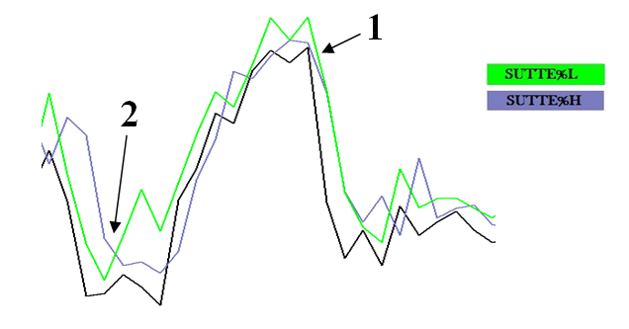
Fig. 1. Movement of Stock of Facebook Inc. 26 September 2014 – 10 November 2014

2.1 Persamaan, rumus, dan code program
Persamaan dan rumus. Semua persamaan dan rumus harus dirujuk dalam teks menggunakan nomor yang berurutan dalam tanda kurung, lihat persamaan (1) sebagai contoh. Persamaan atau rumus yang ditampilkan harus dipusatkan dan disetel pada baris terpisah dengan ruang ekstra di atas dan di bawah dan ditulis dalam Times New Roman 9pt.

a + b = c . (1)

Persamaan dan rumus harus diselingi dengan cara yang sama seperti teks biasa tetapi dengan spasi sebelum tanda baca.

Code. Listing program atau perintah dalam teks diatur dalam font mesin ketik Program listings or commands in the text are set in typewriter font (CMTT10 or Courier) and disebutkan dalam teks.
Contoh Program Komputer dari Motaz Abdel A., [2]
program Project1;
{$mode objfpc}{$H+}
uses
{$IFDEF UNIX}{$IFDEF UseCThreads}
cthreads,
{$ENDIF}{$ENDIF}
Classes { you can add units after this };
{$IFDEF WINDOWS}{$R project1.rc}{$ENDIF}
begin
end.
2.1 Kutipan/Citations dan referensi/references
Citations. Untuk kutipan dalam teks gunakan nomor berurutan dalam tanda kurung siku: [1], [2], [3], etc.
References. Semua referensi harus dalam format yang sama dengan yang ada di bagian akhir dokumen ini dan daftar referensi harus menyertakan semua literatur yang dikutip.

2.1 Acknowledgements
Acknowledgments. Harus diperlakukan sebagai heading level 3 dan tidak boleh diberi nomor.

References
[1] Somov, A.: Judul artikel. Prosiding IOP mengenai Pemrogram Komputer. pp. 1-11 (2011)
[2] Motaz, A.: Pengenalan Pemrograman Web. Vol. 2, pp. 10-11. Penerbit A, Indonesia (2013)
[3] Somov, A.: Judul artikel. Jurnal ABCD. pp. 1-11 (2011)

